

AMERICAN INTERNATIONAL UNIVERSITY- BANGLADESH (AIUB)
Introduction to Electrical Circuit
FALL 2023-2024
Section: L, Group: 07

LAB REPORT ON

Study of Combination of Series-Parallel Circuits and Verification of ∆−Y or Y−∆ Conversion Introduction

Supervised By

MD. SHAHARIAR PARVEZ

Name | ID
1.MD. Abdullah | 22-48065-2
2.Azmir Islam Kafi | 22-47981-2
3.Mohammad Ansar Uddin | 22-47975-2
4.Chinmoy Guha | 22-48056-2
5.Suvra Chakraborty | 22-48067-2

Introduction:
Series-parallel networks are complex electrical circuits that incorporate both series and parallel circuit elements. In these networks, we can analyze series portions using Kirchhoff's Voltage Law (KVL) and the Voltage Divider Rule (VDR), while parallel sections can be evaluated using Kirchhoff's Current Law (KCL) and the Current Divider Rule (CDR). When dealing with a combination of series and parallel components within a network, we can employ a combination of KVL, KCL, VDR, and CDR to solve it.

In the process of solving networks with a substantial number of branches using Kirchhoff's Laws, one may encounter challenges due to the need to handle multiple simultaneous equations. However, for simplification purposes, particularly in intricate networks, we can systematically replace delta meshes with equivalent Y systems and vice versa. This simplification technique aids in making the analysis of complex networks more manageable. And this is exactly what we are going to verify in this experiment.

Apparatus

- Trainer Board
- AVO meter or Multimeter
- DC source
- Resistors
- Connecting Wires

Circuit Diagram:
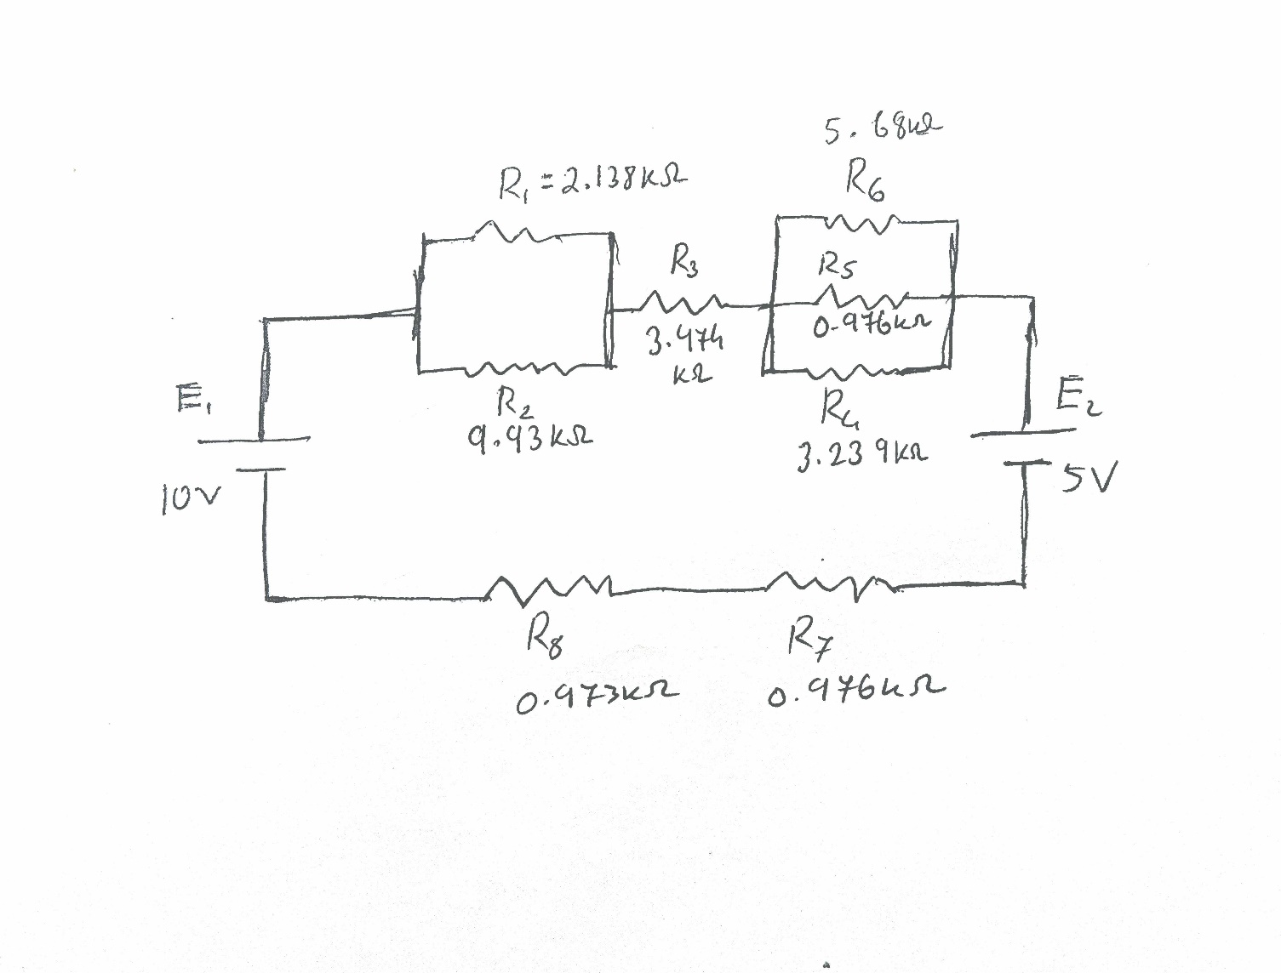

Figure: Diagram 1

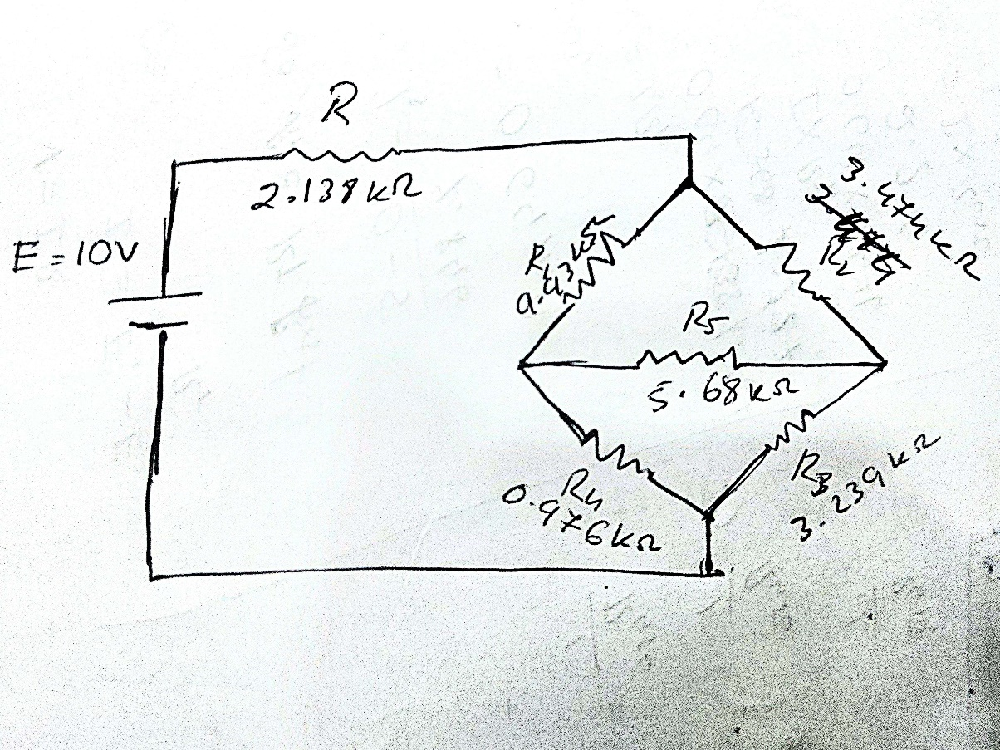

Figure: Diagram 2

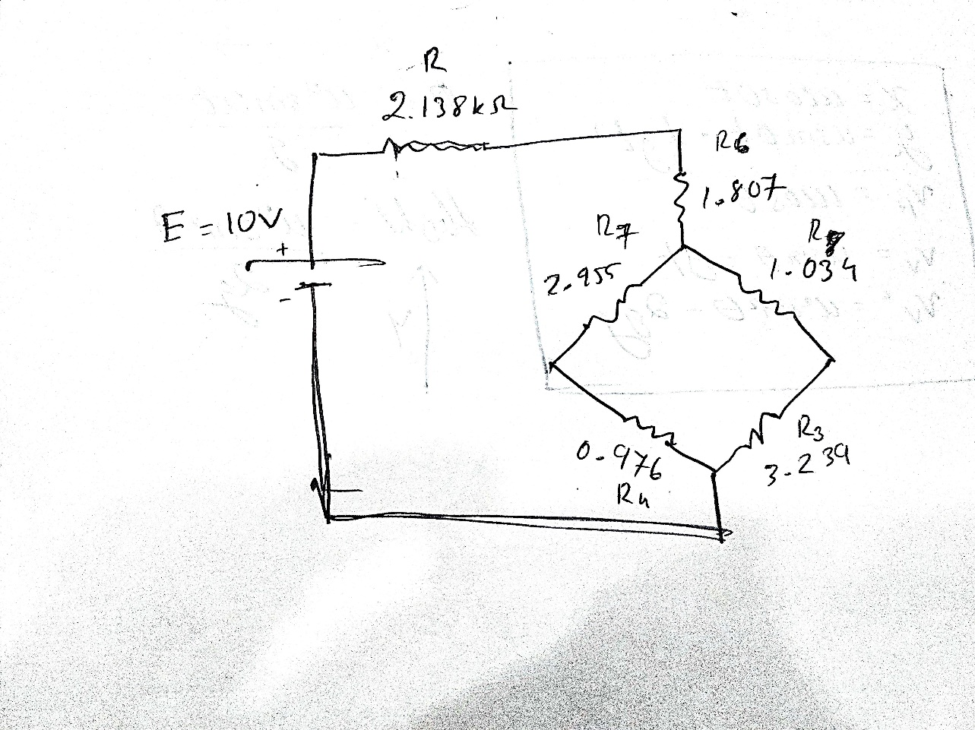

Figure: Diagram 3

Experimental Procedure:

We connected the circuit as shown in the Diagram 1 and the potential difference across each resistance and current of each branch was measured. After that we input the measured data into Table 1.

Next, we connected the circuit as shown in Diagram 2, and the potential difference across each resistance and current of each branch was measured. The total current flow was also taken into account and measured using the multimeter, and the equivalent resistance of the total circuit was determined. Then we input that data into Table 2.
The delta connection of resistors R₁, R₂, and R₅ was then converted into a wye connection of R₆, R₇ and R₈ as shown in Diagram 3. The voltages across each resistance, current through each branch, and equivalent resistance of the total circuit was measured and the corresponding data was set into Table 3.
Then we did a simulation of all 3 circuits using Ni Multisim Software.

Table: 1- for series-parallel connection
Calculated Value |  |  |  |  |  | Measured Value
I | V_{R12} | V_{R3} | V_{R456} | V_{R7} | V_{R8} | I | V_{R12} | V_{R3} | V_{R456} | V_{R7} | V_{R8}
640µA | 1.12v | 2.2v | 0.42v | 0.62v | 0.62v | 680µA | 1.074v | 2.122v | 0.404v | 0.659v | 0.659v

Table: 2- Data table for delta connection
V_{R} | V_{R1} | V_{R2} | V_{R3} | V_{R4} | V_{R5} | I_{R} | I_{R1} | I_{R2} | I_{R3} | I_{R4} | I_{R5}
3.52v | 5.59v | 3.81v | 2.56v | 0.825v | 1.74v | 1.668mA | 0.55mA | 1.11mA | 0.84mA | 0.91mA | 0.32mA

Table: 3- Data table for wye connection
V_{R} | V_{R3} | V_{R4} | V_{R6} | V_{R7} | V_{R8} | I_{R} | I_{R3} | I_{R4} | I_{R6} | I_{R7} | I_{R8}
3.568v | 2.59v | 0.848v | 3.015v | 2.57v | 0.827v | 1.66  mA | 0.79  mA | 0.86  mA | 1.66  mA | 0.86  mA | 0.79  mA

Calculation:
Given,
R₁ = 2.138 kΩ
R₂ = 9.93 kΩ
R₃ = 3.474 kΩ
R₄ = 3.239 kΩ
R₅ = 0.976 kΩ
R₆ = 5.68 kΩ
R₇ = 0.976 kΩ
R₈ = 0.973 kΩ
For Table 1,
R₁₂ = 1.761 kΩ
R₄₅₆ = 0.662 kΩ
Total Resistance, R_{t} = R₁₂+R₃+R₄₅₆+R₇+R₈ = 7.847 kΩ
I = (E1-E2)/R_{t} = 0.64mA
Therefore, according to V=IR,
V_{R12} = 1.127v
V_{R3} = 2.2v
V_{R456} = 0.424v
V_{R7} = 0.624v
V_{R8} = 0.622v

For Table 2,
R = 2.138 kΩ
R₁ = 9.93 kΩ
R₂ = 3.474 kΩ
R₃ = 3.239 kΩ
R₄ = 0.976 kΩ
R₅ = 5.68 kΩ

VR = 3.52v
VR1 = 5.59v
VR2 = 3.81v
VR3 = 2.56v
VR4 = 0.825v
VR5 = 1.74v

So,
𝑉 3.52𝑣
𝐼_{𝑅} = = 1.668𝑚𝐴
𝑅 2.138Ω
𝑉𝑅1
𝐼_{𝑅1} = = 0.562𝑚𝐴
𝑅₁ 𝑉𝑅2
𝐼_{𝑅2} = = 1.106𝑚𝐴
𝑅₂
𝑉𝑅3
𝐼_{𝑅3} = = 0.79𝑚𝐴
𝑅₃

𝑉𝑅4
𝐼_{𝑅4} = = 0.868𝑚𝐴
𝑅₄
𝑉𝑅5
𝐼_{𝑅5} = = 0.3066𝑚𝐴
𝑅₅

ΔY Conversion:
Given,
R₁ = 9.93 kΩ
R₂ = 3.474 kΩ
R₅ = 5.68 kΩ

𝑅₆ = ( 𝑅1 × 𝑅2) / (𝑅1 + 𝑅2 + 𝑅3 ) = 1.807 kΩ
𝑅₇ = ( 𝑅1 × 𝑅5) / (𝑅1 + 𝑅2 + 𝑅3 ) = 2.955 kΩ
𝑅₈ = ( 𝑅2 × 𝑅5) / (𝑅1 + 𝑅2 + 𝑅3 ) = 1.034 kΩ

V_{R} = 3.568 v
V_{R3} = 2.59 v
V_{R4} = 0.848v
V_{R6} = 3.015 v
V_{R7} = 2.57 v
V_{R8} = 0.827v
𝑉
𝐼_{𝑅} = = 1.66𝑚𝐴
𝑅 𝑉𝑅3
𝐼_{𝑅3} = = 0.79𝑚𝐴
𝑅₃ 𝑉𝑅4
𝐼_{𝑅4} = = 0.86𝑚𝐴
𝑅₄
𝑉𝑅6
𝐼_{𝑅6} = = 1.66𝑚𝐴
𝑅₆
𝑉𝑅7
𝐼_{𝑅7} = = 0.86𝑚𝐴
𝑅₇
𝑉𝑅8
𝐼_{𝑅8} = = 0.79𝑚𝐴
𝑅₈

Result:
For Delta connection:
V_{R} = 3.52v
I_{R} =1.67mA
For Δ𝑌 connection:
V_{R} =3.57v
I_{R} =1.66mA
Simulation:
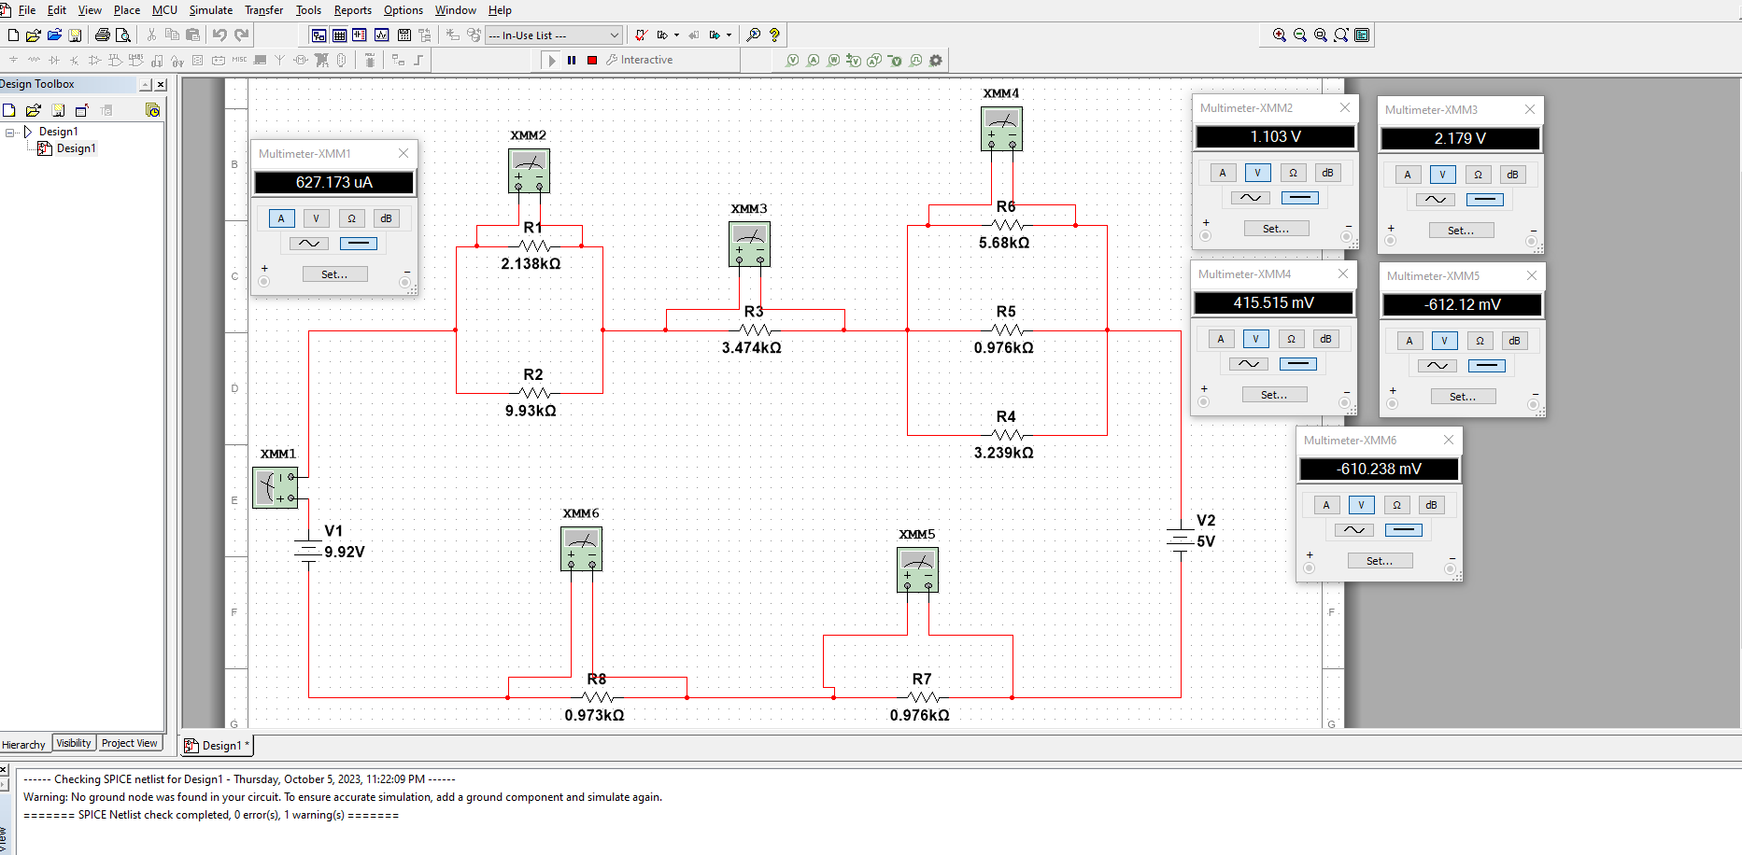

For table 1: Total Current and Voltage across the Resistors.

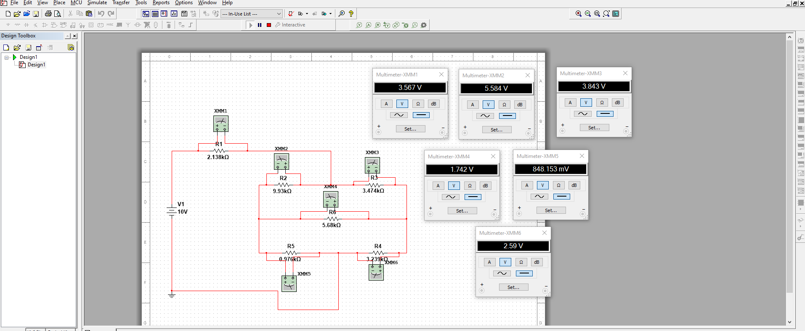

For table 2: Voltage across the Resistors.

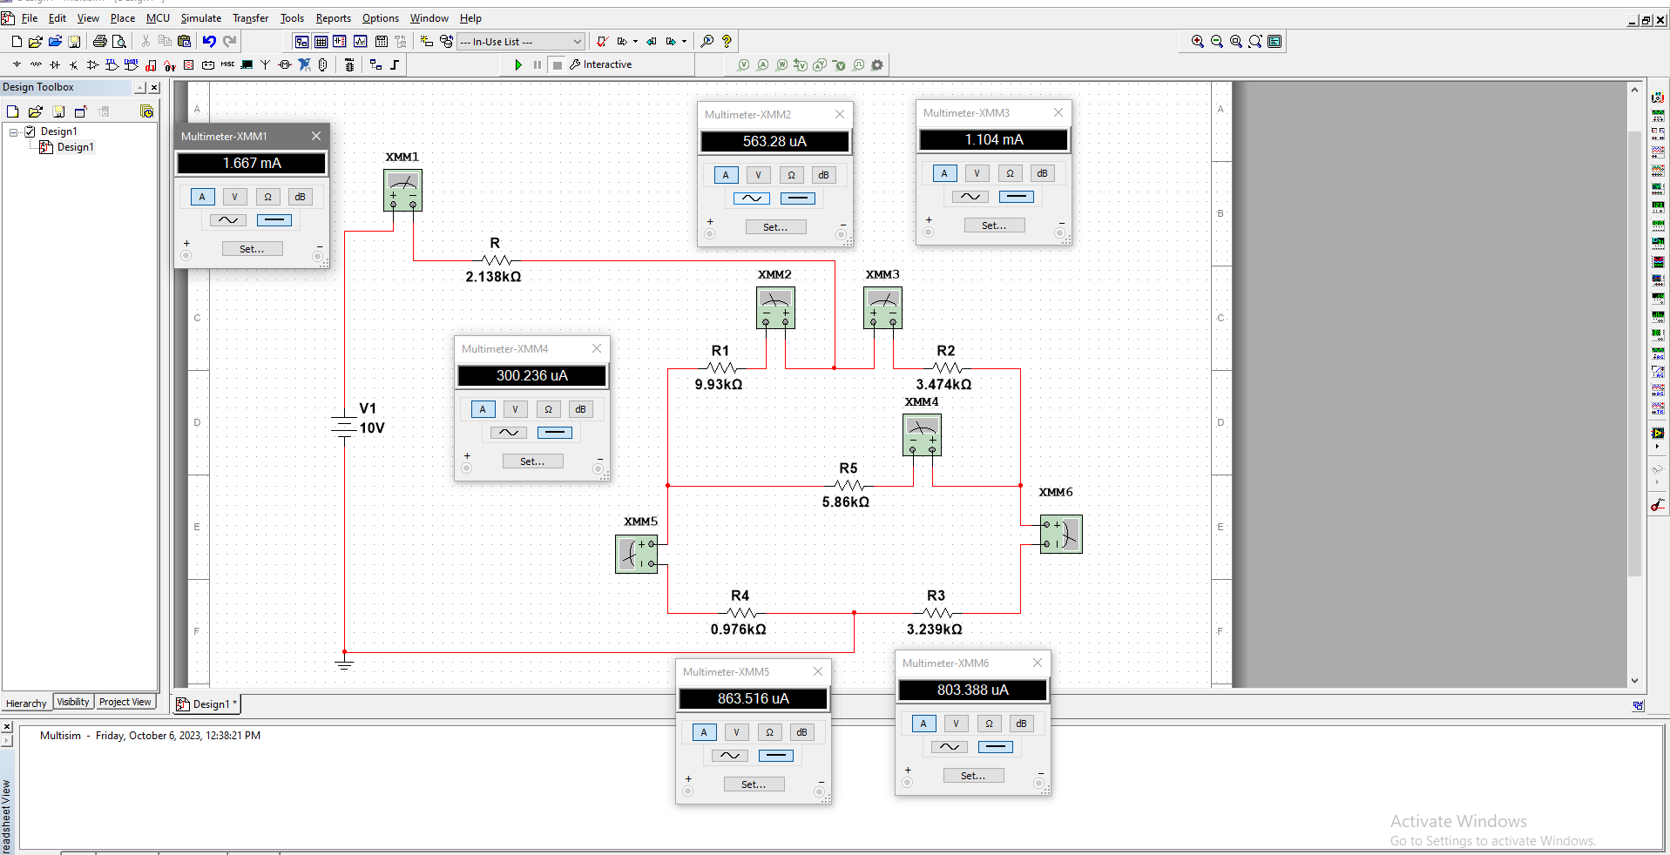
For table 2: Current flow in every branch of the circuit.

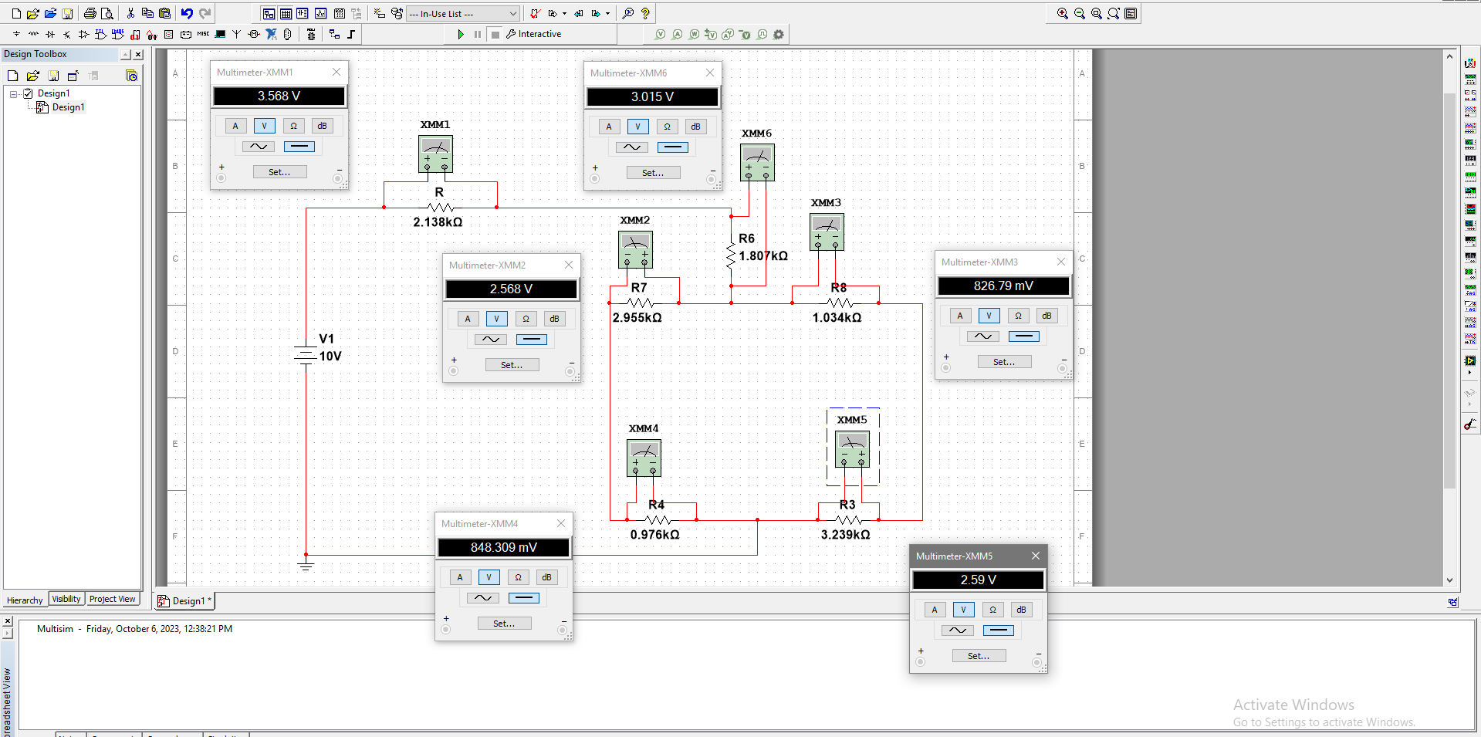
For table 3: Voltage across the Resistors.

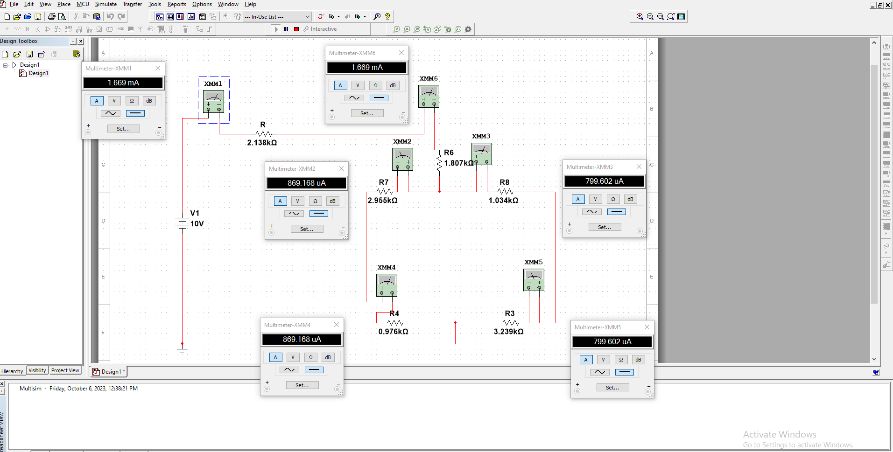
For table 3: Current flow in every branch of the circuit.

Discussion & Conclusion:
We set up the circuit in the breadboard according to diagram 1 and 2 and measured the values in table 1. Then we calculated the same values using formulae and also used Ni Multisim software to simulate these circuits. We could see that our measured and calculated values are quite close and similar to the simulation even though there are a few differences which would be due to the resistance in wires, temperature not being constant, human error and etc. According to the data found, it’s safe to say that we verified Kirchhoff’s Voltage Law (KVL) and Kirchhoff’s Current Law (KCL). While doing the experiment we had to keep in mind not to damage our equipment so the value of the voltage was increased gradually as applying a large voltage can damage the resistors. In the end, the delta - Y conversion formula was verified from the experiment. Therefore, we can conclude that was experiment was indeed successful.

